Image forms of supportive STATA results
Model 1: empty model w/o explanatory variables
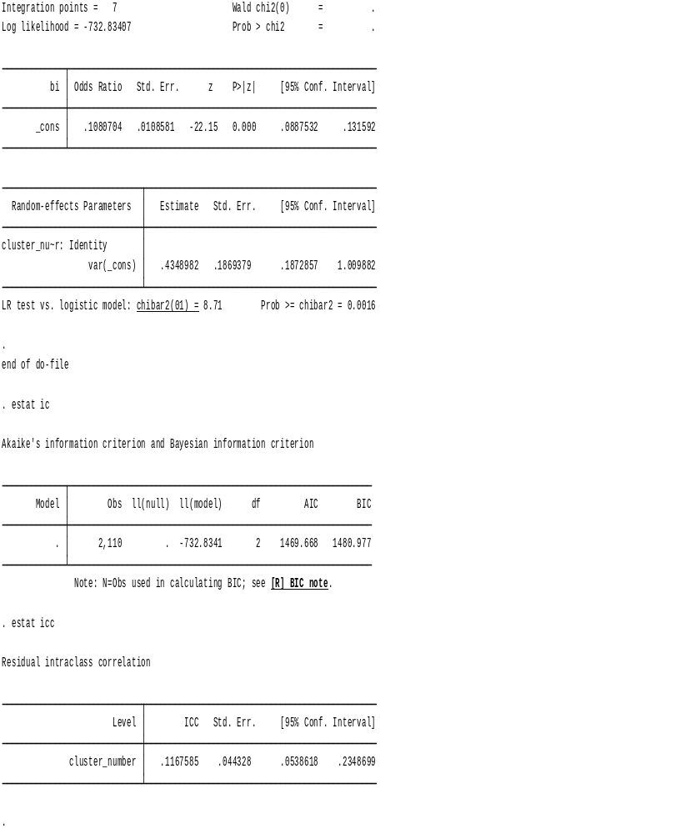

Model 2: individual variables
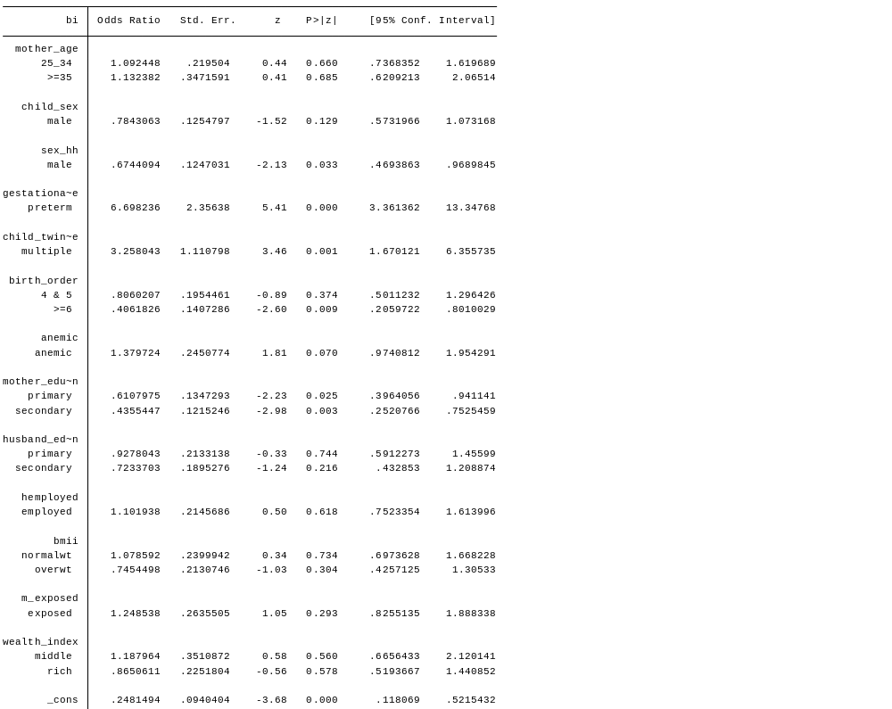
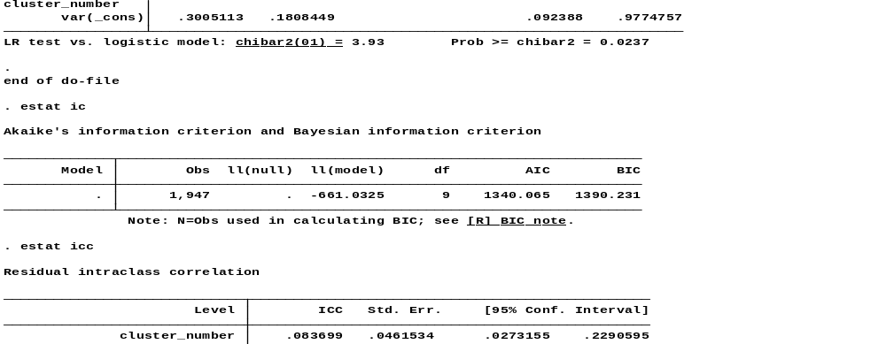

Model 3: Multivariable community variables
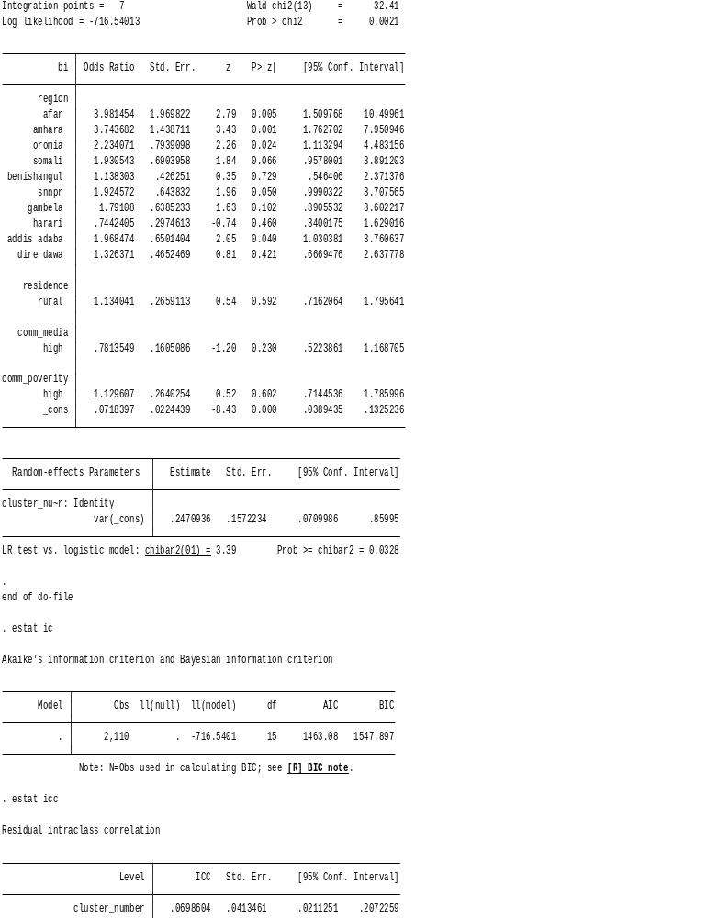
Model 4: Final model multivariable
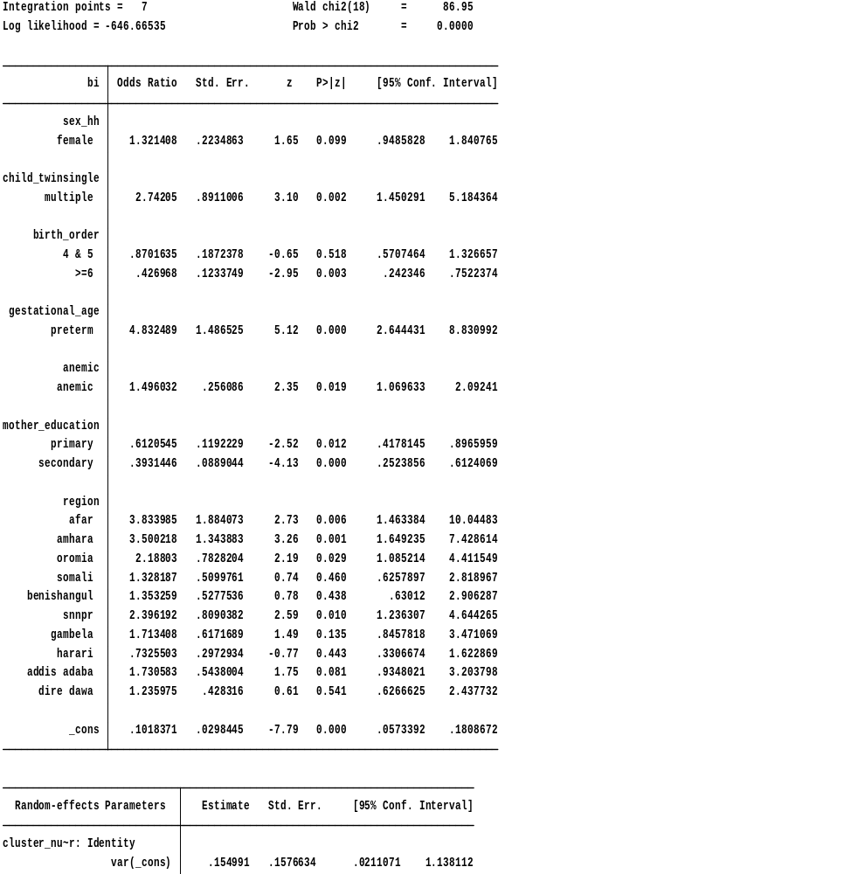
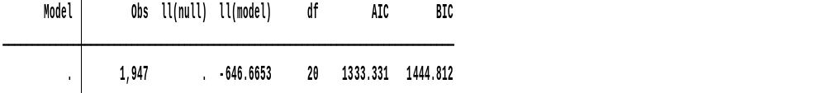
Multi-collinearity
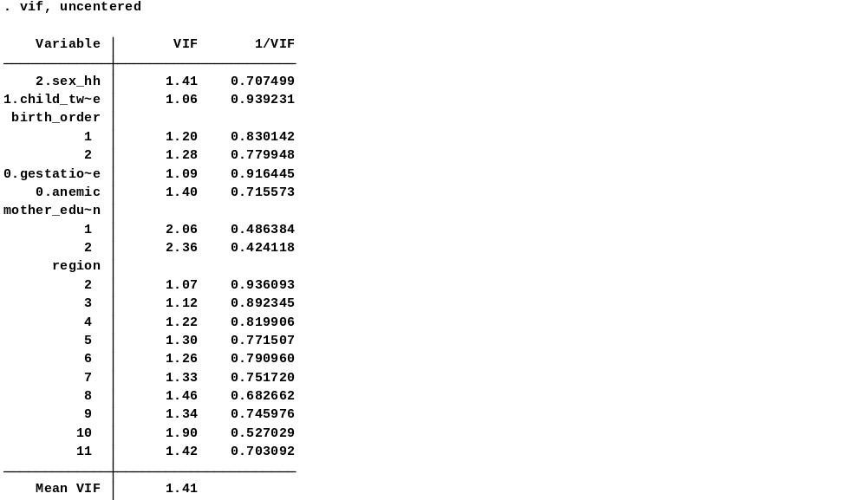
ROC curve to predictive model for determinants low birth weight
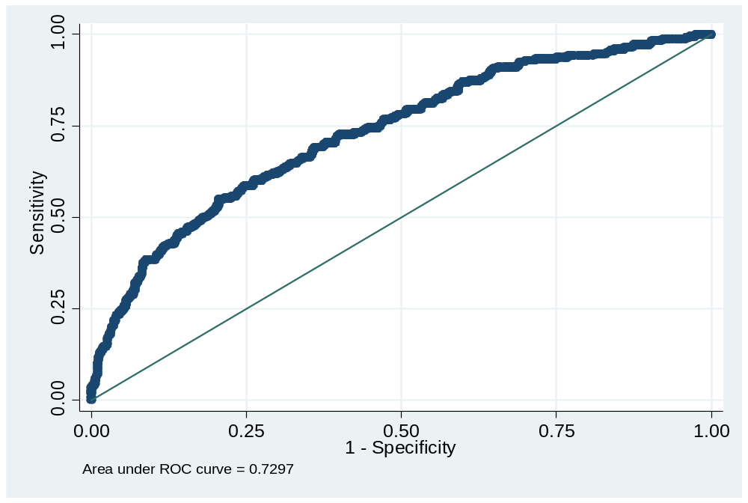
Bivariate multilevel logistic regression result of the individual level factors associated with low birth weight EDHS 2016
Characteristics | COR | (95% CI)
Religion  Others  Orthodox  Protestant  Muslim | Ref  2.32  2.93  2.88 | (0.292-18.359)  (0.367-23.482)  (0.362-22.812)
Age of mother (in year)  15-24years  25-34 years  35 and above years | Ref  0.92  0.76 | (0.664-1.284)  (0.491-1.181)
Member of at household  1-5  6 and above | Ref  0.86 | (0.643-1.160)
Sex of child  Male  Female | Ref  0.75 | (0.565-0.997)
Sex of HH head  Male  Female | Ref  0.76 | (0.560-1.042)
Maternal age at 1st birth  Less than 18 years  18 and above years | Ref  1.11 | (0.799-1.547)
Gestational age at birth  Term  Preterm | Ref  0.20 | (0.109-0.353)
Child is single or twin  Single birth  Multiple birth | Ref  0.28 | (0.156-0.526)
Marital status  Not married  Married | Ref  0.61 | (0.219-1.722)
Birth order  1-3  4-5  6 and above | Ref  1.08  0.67 | (0.729-1.593)  (0.402-1.107)
Smokes cigarettes  No  Yes | Ref  1.87 | (0.375-9.365)
Anemia level  Anemic  Not anemic | Ref  0.67 | (0.491-0.931)
Mothers educational level  No education  Primary  Secondary/higher | Ref  0.79  0.58 | (0.560-1.117)  (0.402-0.849)
Maternal occupation  Employed  Not employed | Ref  0.84 | (0.621-1.143)
Husband education level  No education  Primary  Secondary/higher | Ref  0.78  0.55 | (0.522-1.174)  (0.372-0.822)
Husband/partner's occupation  Not employed  Employed | Ref  0.78 | (0.570-1.067)
Nutritional status  Underweight  Normal  Overweight/obese | Ref  1.03  0.68 | (0.690-1.533)  (0.415-1.098)
wealth index  Poor  Middle  Rich | Ref  1.23  0.70 | (0.728-2.074)  (0.483-1.024)
Media exposure  Not exposed  Exposed | Ref  0.82 | (0.601-1.112)

Bivariate multilevel logistic regression result of the community level factors associated with LBW EDHS 2016
Characteristics | COR | (95% CI)
Region  Tigray  Afar  Amhara  Oromia  Somali  Benishangul  SNNPR  Gambela  Harari  Addis Ababa  Dire Dawa | Ref  3.45  3.41  2.15  1.96  1.25  1.97  1.82  0.64  1.47  1.17 | (1.324-8.969)  (1.616-7.183)  (1.073-4.320)  (0.972-3.949)  (0.601-2.613)  (1.022-3.813)  (0.918-3.627)  (0.294-1.386)  (0.818-2.646)  (0.597-2.288)
Residence  Urban  Rural | Ref  1.32 | (0.958-1.810)
Community poverty  Low  High | Ref  1.47 | (1.075-2.023)
Community education  Low  High | Ref  1.10 | (0.633-1.925)
Community media exposure  Low  High | Ref  0.71 | (0.521-0.982)

